Assignment 27

Web API Service Deployment

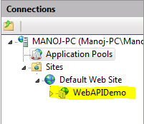



Web Client Code changes for URL